**Project Overview:**

*In this capstone, we will predict if the Falcon 9 first stage will land successfully. SpaceX advertises Falcon 9 rocket launches on its website with a cost of 62 million dollars; other providers cost upward of 165 million dollars each, much of the savings is because SpaceX can reuse the first stage. Therefore, if we can determine if the first stage will land, we can determine the cost of a launch. This information can be used if an alternate company wants to bid against SpaceX for a rocket launch. In this lab, you will collect and make sure the data is in the correct format from an API.*

## Overview of the DataSet

SpaceX has gained worldwide attention for a series of historic milestones.

It is the only private company ever to return a spacecraft from low-earth orbit, which it first accomplished in December 2010. SpaceX advertises Falcon 9 rocket launches on its website with a cost of 62 million dollars wheras other providers cost upward of 165 million dollars each, much of the savings is because Space X can reuse the first stage.

Therefore, if we can determine if the first stage will land, we can determine the cost of a launch.

This information can be used if an alternate company wants to bid against SpaceX for a rocket launch.

This dataset includes a record for each payload carried during a SpaceX mission into outer space.

The following is an example of a successful and launch.



Several examples of an unsuccessful landing are shown here:



Falcon 9 Rocket Family:

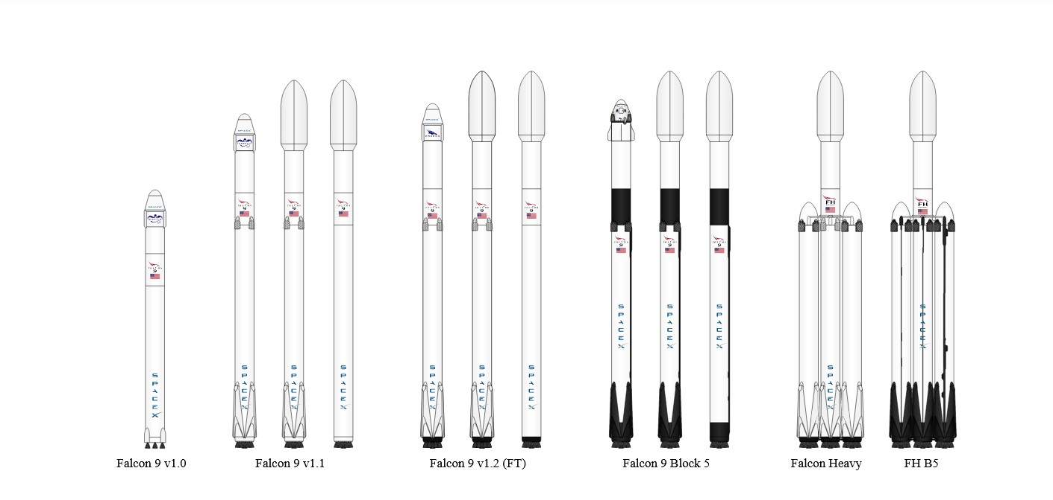

# **Space X Falcon 9 First Stage Landing Prediction**

In the data set, there are several different cases where the booster did not land successfully. Sometimes a landing was attempted but failed due to an accident; for example, True Ocean means the mission outcome was successfully landed to a specific region of the ocean while False Ocean means the mission outcome was unsuccessfully landed to a specific region of the ocean. True RTLS means the mission outcome was successfully landed to a ground pad False RTLS means the mission outcome was unsuccessfully landed to a ground pad.True ASDS means the mission outcome was successfully landed on a drone ship False ASDS means the mission outcome was unsuccessfully landed on a drone ship.

The data contains several Space X launch facilities: [Cape Canaveral Space](https://en.wikipedia.org/wiki/List_of_Cape_Canaveral_and_Merritt_Island_launch_sites) Launch Complex 40 **VAFB SLC 4E** , Vandenberg Air Force Base Space Launch Complex 4E **(SLC-4E)**, Kennedy Space Center Launch Complex 39A **KSC LC 39A** .The location of each Launch Is placed in the column LaunchSite

* **LEO**: Low Earth orbit (LEO)is an Earth-centred orbit with an altitude of 2,000 km (1,200 mi) or less (approximately one-third of the radius of Earth),[1] or with at least 11.25 periods per day (an orbital period of 128 minutes or less) and an eccentricity less than 0.25.[2] Most of the manmade objects in outer space are in LEO [[1]](https://en.wikipedia.org/wiki/Low_Earth_orbit).
* **VLEO**: Very Low Earth Orbits (VLEO) can be defined as the orbits with a mean altitude below 450 km. Operating in these orbits can provide a number of benefits to Earth observation spacecraft as the spacecraft operates closer to the observation[[2]](https://www.researchgate.net/publication/271499606_Very_Low_Earth_Orbit_mission_concepts_for_Earth_Observation_Benefits_and_challenges).
* **GTO** A geosynchronous orbit is a high Earth orbit that allows satellites to match Earth's rotation. Located at 22,236 miles (35,786 kilometers) above Earth's equator, this position is a valuable spot for monitoring weather, communications and surveillance. Because the satellite orbits at the same speed that the Earth is turning, the satellite seems to stay in place over a single longitude, though it may drift north to south,” NASA wrote on its Earth Observatory website [[3]](https://www.space.com/29222-geosynchronous-orbit.html) .
* **SSO (or SO)**: It is a Sun-synchronous orbit also called a heliosynchronous orbit is a nearly polar orbit around a planet, in which the satellite passes over any given point of the planet's surface at the same local mean solar time [[4]](https://en.wikipedia.org/wiki/Sun-synchronous_orbit) .
* **ES-L1** :At the Lagrange points the gravitational forces of the two large bodies cancel out in such a way that a small object placed in orbit there is in equilibrium relative to the center of mass of the large bodies. L1 is one such point between the sun and the earth [[5]](https://en.wikipedia.org/wiki/Lagrange_point#L1_point) .
* **HEO** A highly elliptical orbit, is an elliptic orbit with high eccentricity, usually referring to one around Earth [[6]](https://en.wikipedia.org/wiki/Highly_elliptical_orbit).
* **ISS** A modular space station (habitable artificial satellite) in low Earth orbit. It is a multinational collaborative project between five participating space agencies: NASA (United States), Roscosmos (Russia), JAXA (Japan), ESA (Europe), and CSA (Canada) [[7]](https://en.wikipedia.org/wiki/International_Space_Station)
* **MEO** Geocentric orbits ranging in altitude from 2,000 km (1,200 mi) to just below geosynchronous orbit at 35,786 kilometers (22,236 mi). Also known as an intermediate circular orbit. These are "most commonly at 20,200 kilometers (12,600 mi), or 20,650 kilometers (12,830 mi), with an orbital period of 12 hours [[8]](https://en.wikipedia.org/wiki/List_of_orbits)
* **HEO** Geocentric orbits above the altitude of geosynchronous orbit (35,786 km or 22,236 mi) [[9]](https://en.wikipedia.org/wiki/List_of_orbits)
* **GEO** It is a circular geosynchronous orbit 35,786 kilometres (22,236 miles) above Earth's equator and following the direction of Earth's rotation [[10]](https://en.wikipedia.org/wiki/Geostationary_orbit)
* **PO** It is one type of satellites in which a satellite passes above or nearly above both poles of the body being orbited (usually a planet such as the Earth [[11]](https://en.wikipedia.org/wiki/Polar_orbit)

some are shown in the following plot:

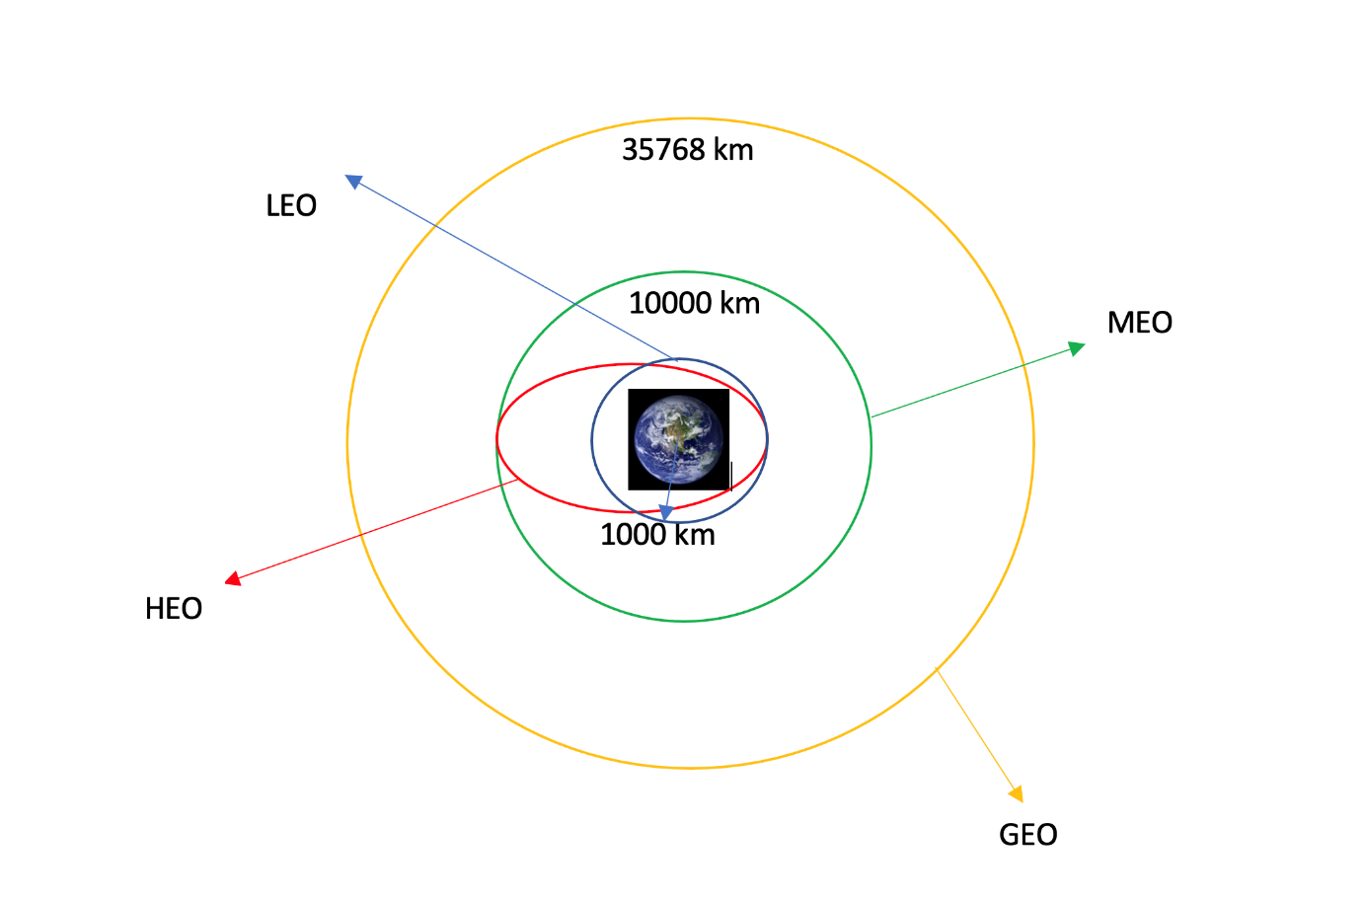

### Occurrence of mission outcome of the orbits:

True Ocean means the mission outcome was successfully landed to a specific region of the ocean while False Ocean means the mission outcome was unsuccessfully landed to a specific region of the ocean. True RTLS means the mission outcome was successfully landed to a ground pad False RTLS means the mission outcome was unsuccessfully landed to a ground pad.True ASDS means the mission outcome was successfully landed to a drone ship False ASDS means the mission outcome was unsuccessfully landed to a drone ship. None ASDS and None None these represent a failure to land.